- Develop and Deploy simple website on EC2-Linux instance with http server which will be only accessible on port 80 by creating security group.

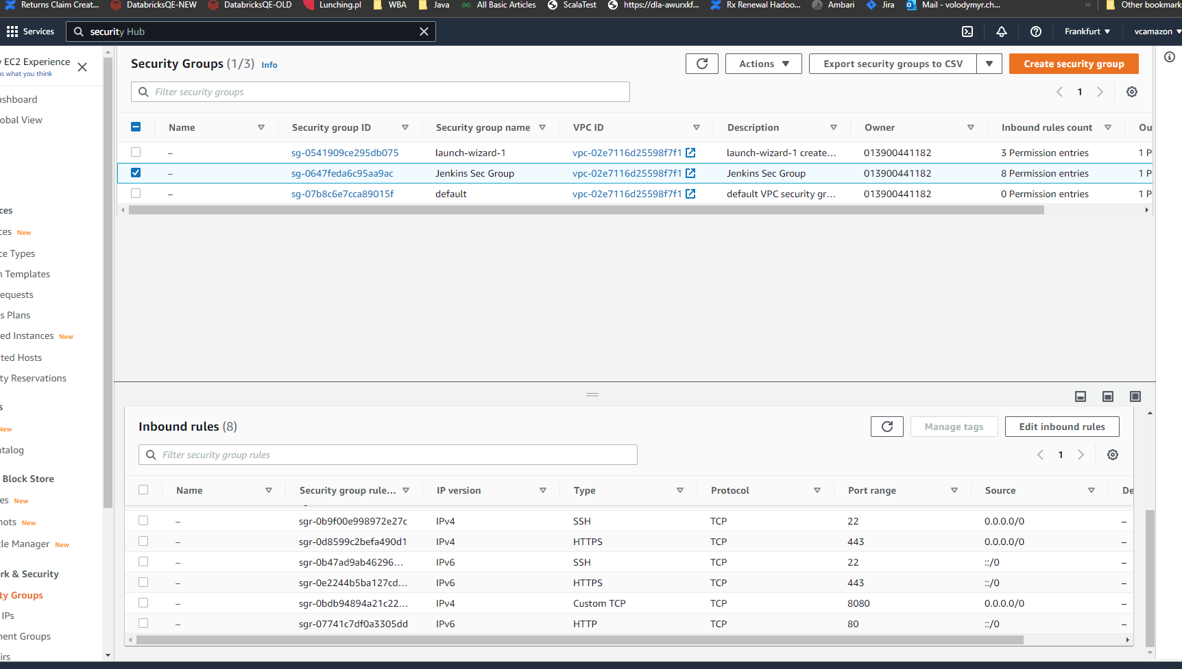

2. Create AMI of EC2 instance created in Assignment1 and configure autoscaling for maximum 2 nodes based on appropriate CPU metric threshold value.Create loadbalancer to distribute load in round robin method /use application and network LB

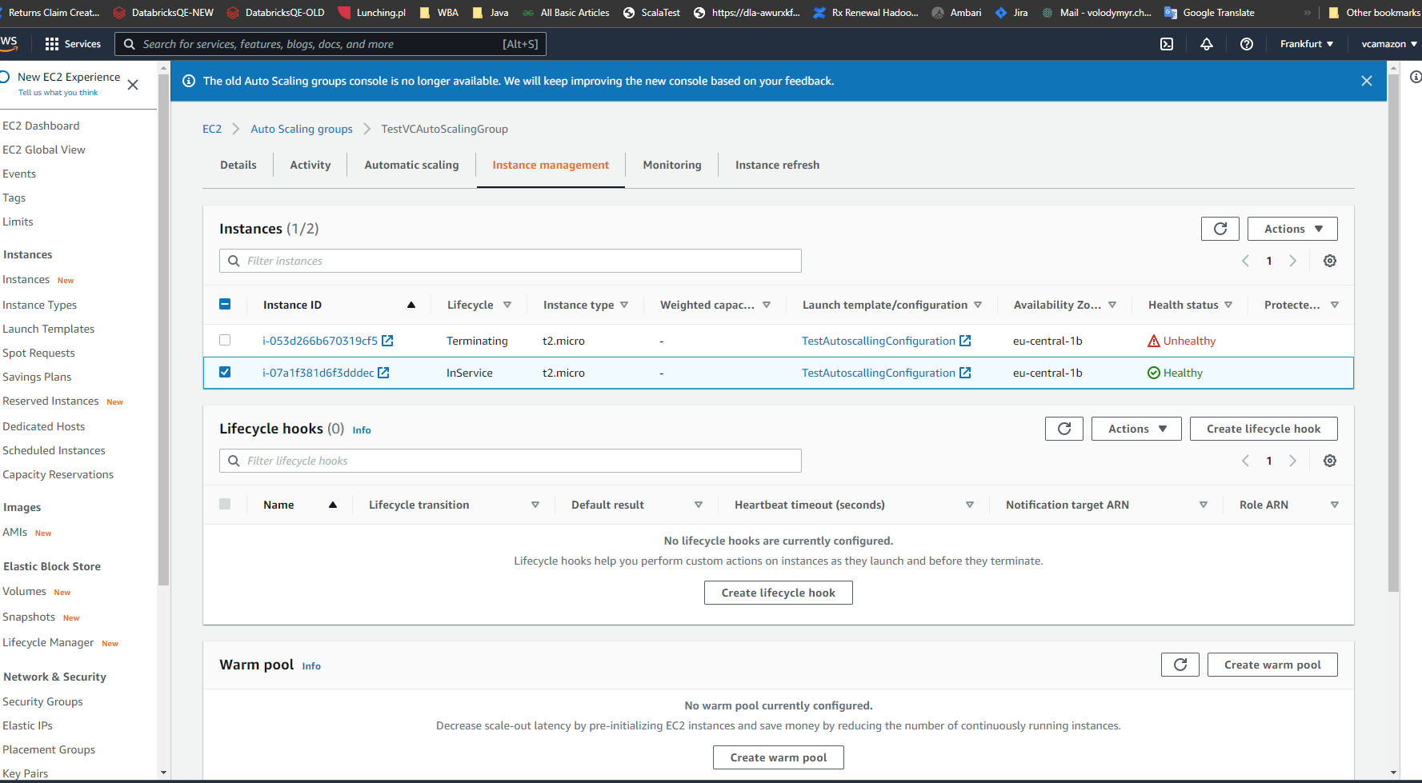
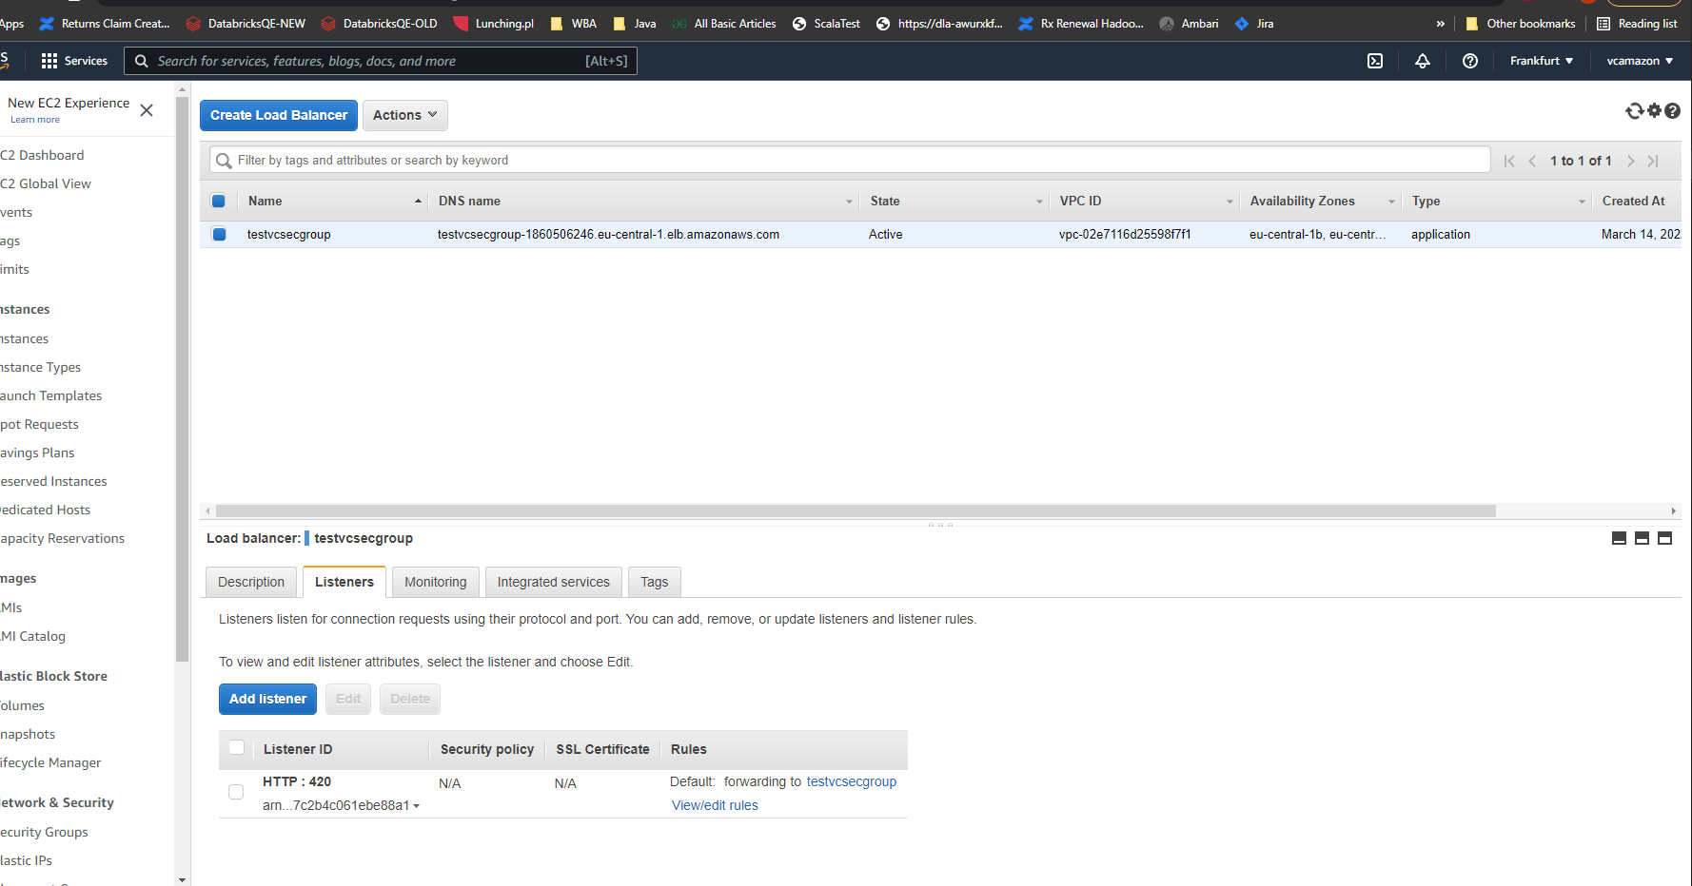

- Create hosted zone using Route53 and access website using appropriate domainname such as yourname.globallogic.com
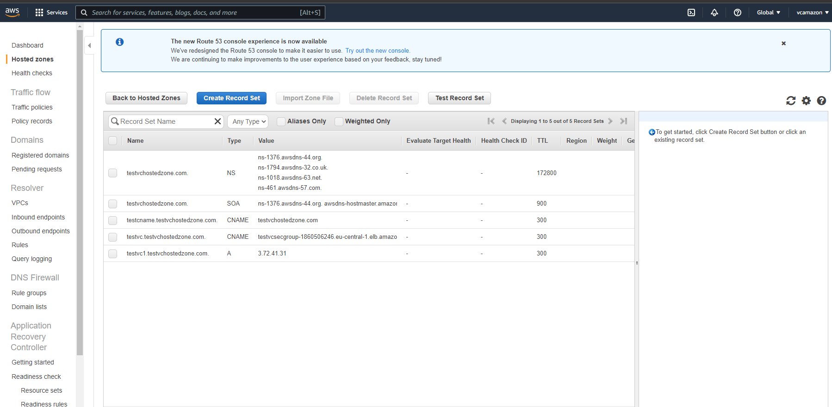
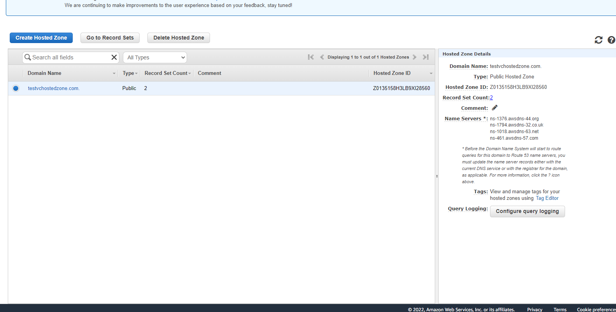
- Deploy simple application using AWS lambada function

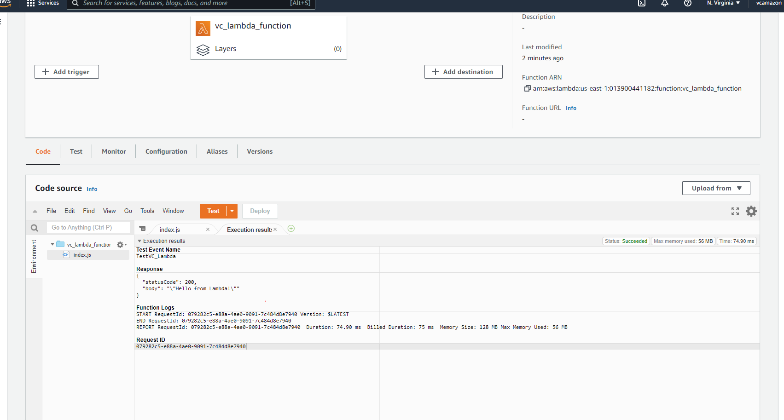
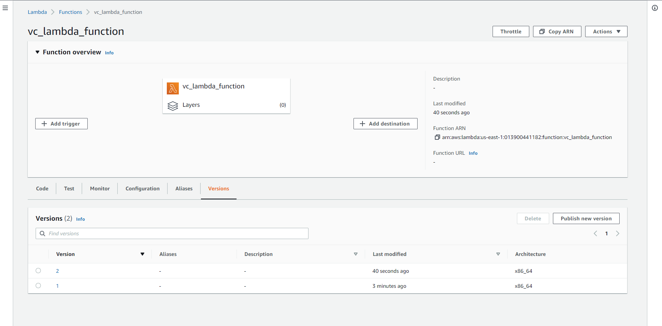

5 Configure s3 bucket to host static website , upload and download index.html, images ,etc from your local machine to s3 bucket

- Create VPC named as your name (e.g john), add two different subnets such as yourname-web accessible over internet and yourname-db (not accessible over internet) , deploy ec2 instance and launch website in yourname-web subnet.
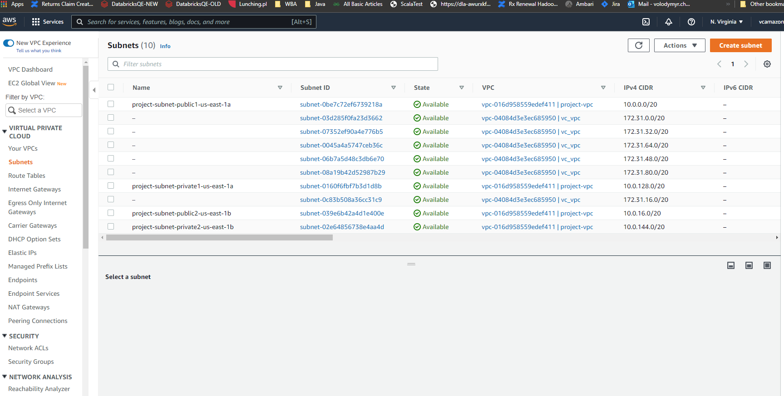

- Deploy Ansible server with two clients
- 8. Run ansible adhoc commands to find hostnames, ipaddresses and Kernel version of all hosts

ubuntu@ip-172-31-25-4:~$ ansible-playbook -i hosts remplb_hostname.yml
[WARNING]: While constructing a mapping from /home/ubuntu/remplb_hostname.yml, line 2, column 3, found a duplicate dict key (tasks). Using last defined value only.

PLAY [all] *****************************************************************************************************************************************************************************

TASK [Gathering Facts] *****************************************************************************************************************************************************************
[WARNING]: Platform linux on host ec2-user@3.124.186.109 is using the discovered Python interpreter at /usr/bin/python3.7, but future installation of another Python interpreter could
change the meaning of that path. See https://docs.ansible.com/ansible-core/2.12/reference_appendices/interpreter_discovery.html for more information.
ok: [ec2-user@3.124.186.109]
ok: [localhost]

TASK [Check the ip of the server] ******************************************************************************************
changed: [localhost]

PLAY RECAP *****************************************************************************************************************************************************************************
ec2-user@3.124.186.109 : ok=2 changed=0 unreachable=0 failed=0 skipped=0 rescued=0 ignored=1
localhost : ok=2 changed=1 unreachable=0 failed=0 skipped=0 rescued=0 ignored=0

ubuntu@ip-172-31-25-4:~/ansible-playbooks/apache_ubuntu1804$ ansible-playbook playbook.yml -l server1 -u vc
[WARNING]: No inventory was parsed, only implicit localhost is available
[WARNING]: provided hosts list is empty, only localhost is available. Note that the implicit localhost does not match 'all'
[WARNING]: Could not match supplied host pattern, ignoring: server1

PLAY [all] ***********************************************************************************************************************************************************
skipping: no hosts matched

PLAY RECAP ***********************************************************************************************************************************************************

12.
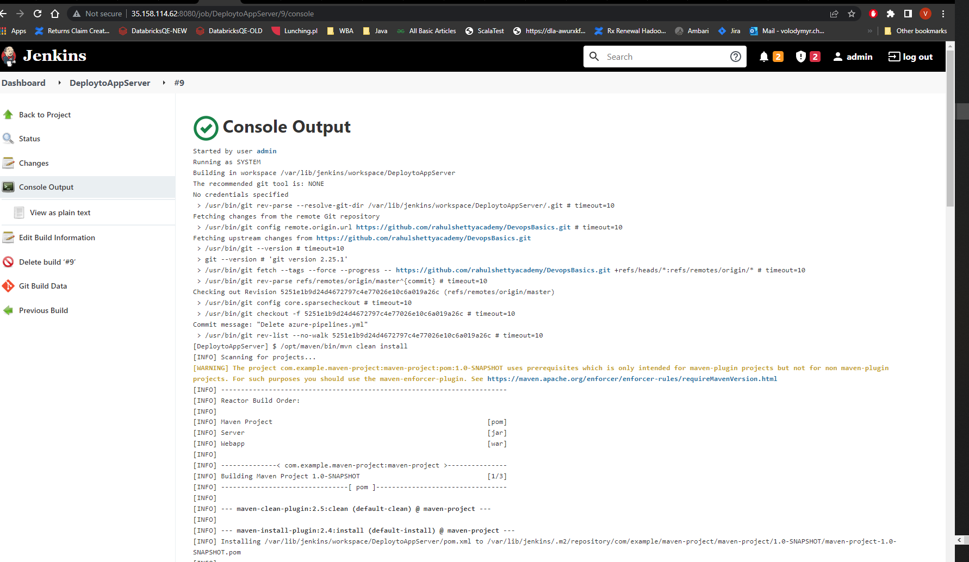

14.Deploy Teraform and write terraform scripts to create VM on AWS
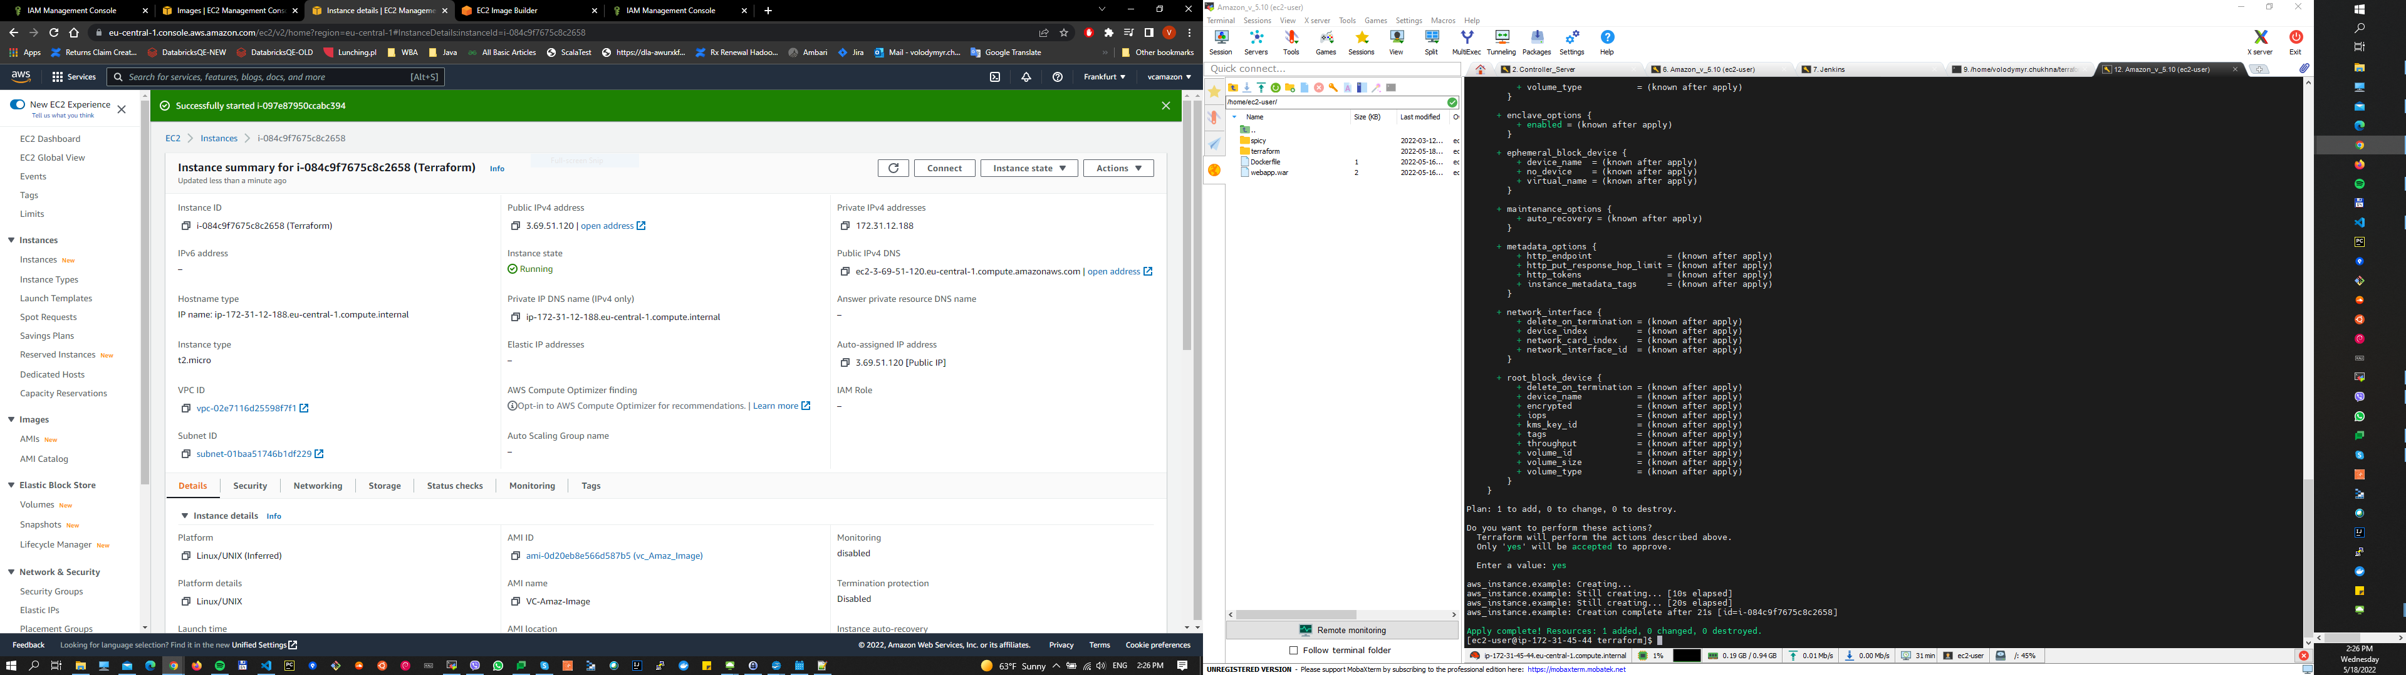
15/16.Use Cloudformation templates to deploy VPC on AWS

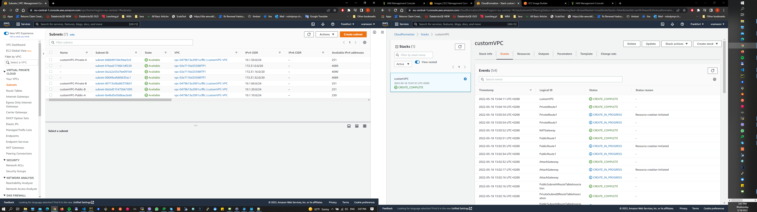

17.Deploy K8s Cluster using EKS
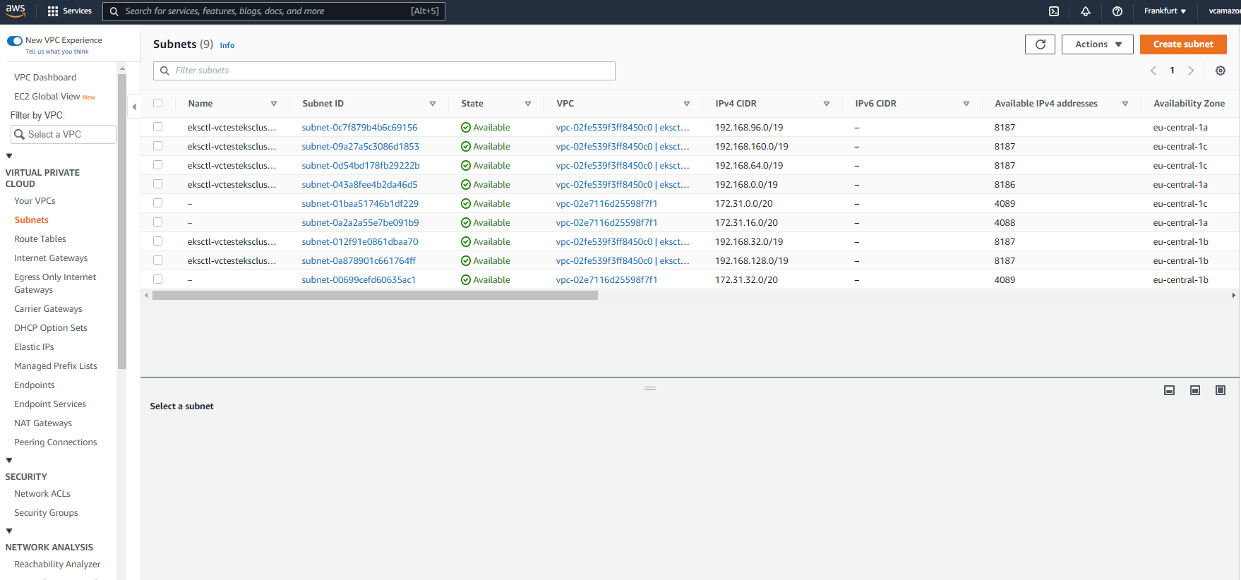
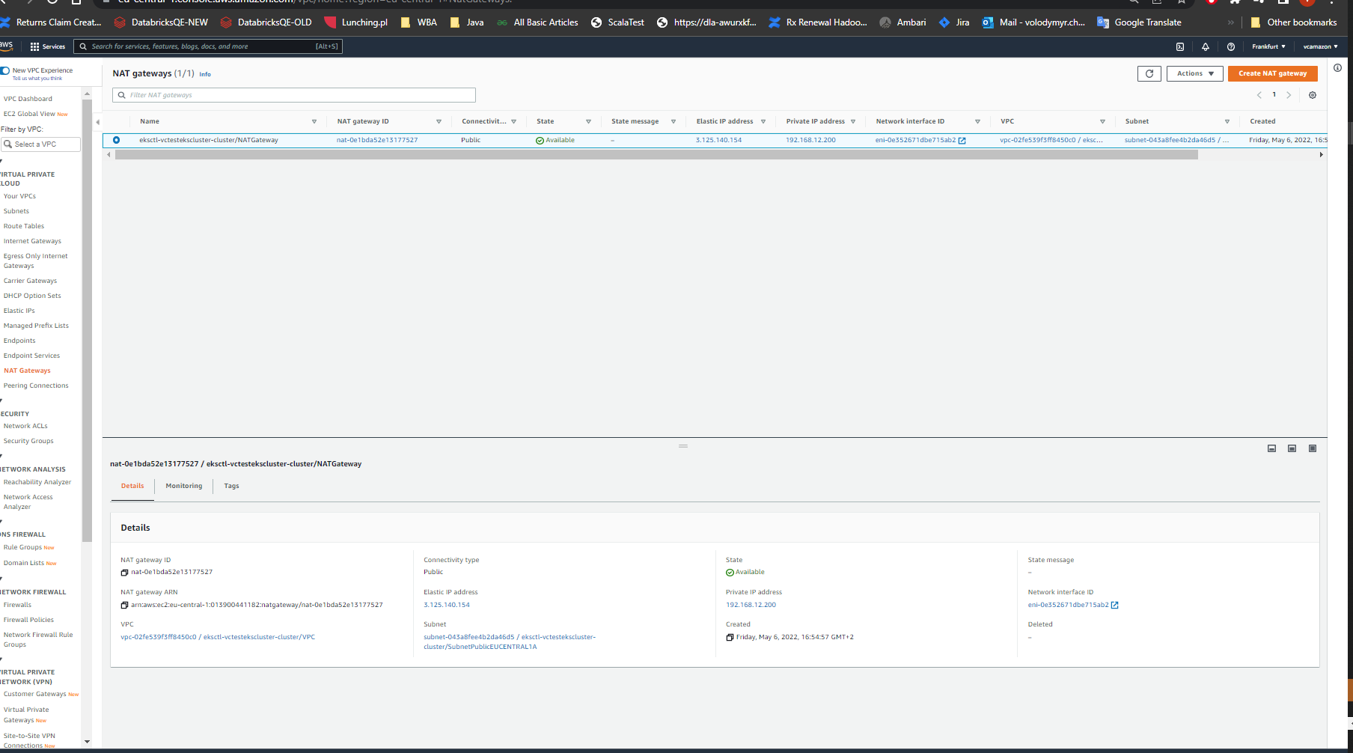
18.

19.



